**DAILY ONLINE ACTIVITIES SUMMARY**

|  |  |  |  |  |  |  |  |
| --- | --- | --- | --- | --- | --- | --- | --- |
| **Date:** | **9/06/2020** | | | | **Name:** | **Shashikant Chavan** | |
| **Sem & Sec** | **8th B** | | | | **USN:** | **4AL16C090** | |
| Online Test Summary | | | | | | | |
| **Subject** | | **BDA** | | | | | |
| **Max. Marks** | | **30** | | **Score** | | **25** | |
| Certification Course Summary | | | | | | | |
| **Course** | **Python Prohramming in Hindi** | | | | | | |
| **Certificate Provider** | | | **GreatLearning** | **Duration** | | | **26 hrs** |
| Coding Challenges | | | | | | | |
| **Problem Statement:** 1) Python Program to Shuffle Deck of Cards | | | | | | | |
| **Status: Solved** | | | | | | | |
| **Uploaded the report in Github** | | | | **YES** | | | |
| **If yes Repository name** | | | | **Shashikant_chavan** | | | |
| **Uploaded the report in slack** | | | | **YES** | | | |

Online test detail:

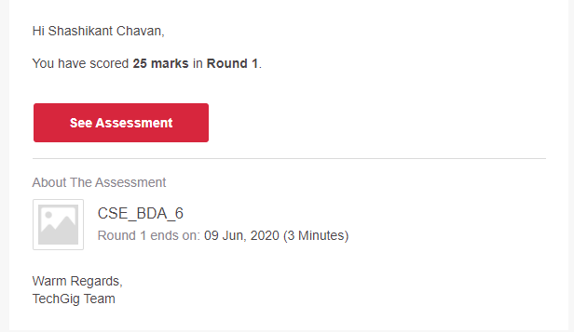

**Certification Course Details:**

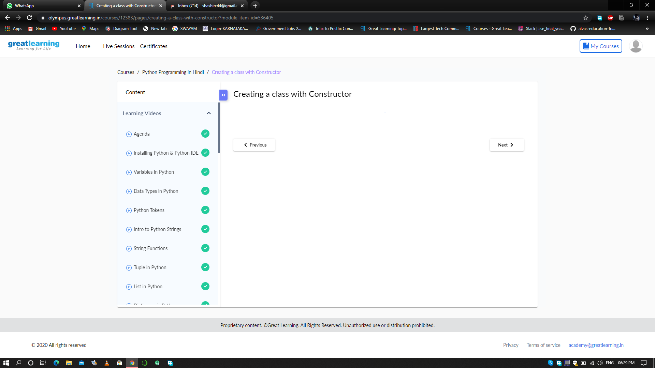

# CODE:

Program no:1

# Python program to shuffle a deck of card

# importing modules

import itertools, random

# make a deck of cards

deck = list(itertools.product(range(1,14),['Spade','Heart','Diamond','Club']))

# shuffle the cards

random.shuffle(deck)

# draw five cards

print("You got:")

for i in range(5):

print(deck[i][0], "of", deck[i][1])